The Law, Disability & Social Change Project Annual Report
2024-2025 Academic Year


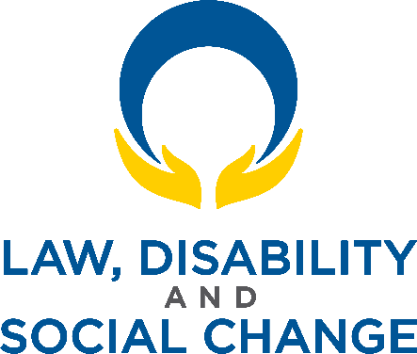
Contents
Land Acknowledgement 2
Message From the Director 3
University of Windsor, Faculty of Law 5
Our Mission 5
Our Vision 5
Our Values 5
About The Law, Disability & Social Change Project 6
Events from the 2024-2025 Academic Year 7
■ Leadership in Canadian Disabled Youth Advocacy: Pathways and Intersections 7
Human Rights Tribunal Disability Case Summaries 8
■ May and June 2024 (Summer, 2024, Issue 1) 8
■ July and August 2024 (Summer, 2024, Issue 2) 8
■ May and June 2025 (Summer, 2025, Issue 1) 8
Current LDSC Project Team Members 9
Advisory Council 14
Acknowledgements 16

Land Acknowledgement
The University of Windsor sits on the traditional territory of the Three Fires Confederacy of First Nations, which includes the Ojibwa, the Odawa, and the Potawatomi. We respect the longstanding relationships with First Nations people in this place in the 100-mile Windsor-Essex peninsula and the straits – les détroits – of Detroit.

Message From the Director
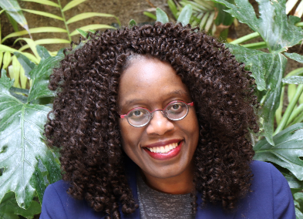
As the Director of The Law, Disability & Social Change (LDSC) Project, it is my sincere pleasure to present the 2024–2025 annual report.
The LDSC Project is a research centre at the University of Windsor, Faculty of Law (Windsor Law). It was founded in 2014. Our vision is to foster and develop inclusive communities that respect and further the rights of persons with disabilities. We accomplish this vision through research, education and raising awareness.
This past year has been business as usual as we pursued our vision. We focused on two specific projects. The first was hosting a dynamic panel on youth disability rights leadership and advocacy in Canada. Starting from the premise that the UN Convention on the Rights of Persons with Disabilities does not explicitly address youth (aged 15 to 24), we invited our guest panelists who are from this demographic and leaders in the disability rights movement in Canada to speak about what is important to young adults with disabilities. Our guests were thoughtful and insightful and spoke from perspectives of diversity, intersectionality and inclusion.
Our second project was to continue our long-standing digest of human rights tribunal cases on disability. This resource, which is researched and written by law students at the centre, is published every summer on our website. The digest has been a helpful tool for disability community members and organizations dedicated to disability issues.
The LDSC research centre could not exist without the dedicated attention and work of our students. Law students from Windsor Law work on a variety of projects relating to law and disability each year. Some years, we have also been able to include law students from other universities as part of the team of student research assistants. I am grateful to them.
Moreover, in 2024-2025, we were joined by two new Executive Research Coordinators (ERCs). ERCs manage some of the major projects of the centre as well as the centre’s day-to-day tasks. They also help supervise our students, providing them with valuable mentorship guidance and mentorship. I am delighted that Florence Kwok ((she/her) JD 2024) and Deborah Willoughby ((she/her) JD/MSW 2021) have joined our team. Both were student researchers with the LDSC Project during their law school careers and are currently practising lawyers. I am grateful to both of them for their dedication and hard work, which they provide as volunteers.
I am equally grateful for the input and insights of our Advisory Council who are individuals from the disability community and from organizations dedicated to disability issues – groups that are not mutually exclusive. They provide us with helpful and grounded advice.
Finally, we would not be able to do the work that we do without funding. We are thankful for the generous support provided by Windsor Law, the Law Foundation of Ontario, and various external research grants over the years. This generosity has helped make our initiatives and projects achievable and successful.
Please read on for additional information all that has been mentioned in this message. We hope that you enjoy this annual report!
Sincerely yours,

Laverne Jacobs, PhD (she/her/elle)
Director
The Law, Disability & Social Change Project
Professor of Law
Windsor Law, University of Windsor | CANADA

University of Windsor, Faculty of Law

Our Mission
To educate ethical, justice-seeking lawyers through teaching, research, advocacy and service.

Our Vision
An enriching educational experience where thought, action and analysis inspire a community that is passionate about using their legal knowledge to achieve a more just and equitable world.

Our Values
Windsor Law is…
People-Centered: Putting people and their experiences at the centre of legal education.
Community-Engaged: Advancing the theory and practice of law at the Canada-US border and in relationship with our local, national and transnational communities.
Dynamic: Using law as an adaptive tool for social change within a comprehensive rigorous legal education.
Justice-Seeking: Building on a long-standing commitment to social justice that seeks fairness, equity and dignity, with a particular focus on relationships with historically marginalized communities.
Inclusive: Offering robust student support as part of a broader commitment to striving for accessible legal education that is engaging, warm and welcoming.

About The Law, Disability & Social Change Project
The Law, Disability & Social Change (LDSC) Project team conducts research into current legal and policy issues to help empower people with disabilities to fully achieve their rights and, more generally, to foster and develop inclusive communities. The LDSC Project focuses on listening to, incorporating and respecting the voices of people with disabilities and aims to further the motto “nothing about us without us”. The LDSC Project team undertakes a variety of projects that feed grounded research and theory into policy development and legal decision-making. The LDSC Project is directed by Professor Laverne Jacobs at the University of Windsor, Faculty of Law. Additional information about The LDSC Project may be found at https://lawdisabilitysocialchange.com/about/, and the team can be contacted at lawdisabilitysocialchange@gmail.com.

Events from the 2024-2025 Academic Year

Leadership in Canadian Disabled Youth Advocacy: Pathways and Intersections

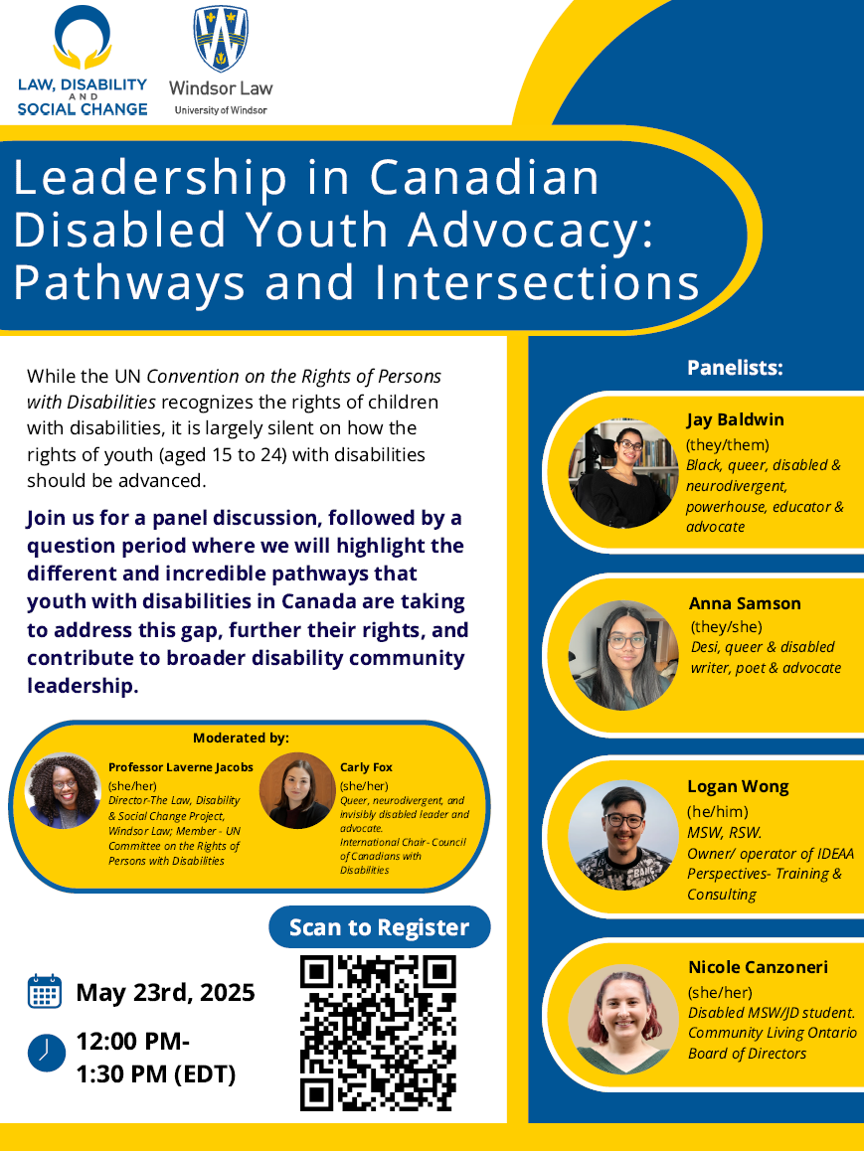
On May 23rd, 2025, The LDSC Project hosted Leadership in Canadian Disabled Youth Advocacy: Pathways and Intersections, a panel discussion with outstanding youth disability advocates.
While The UN Convention on the Rights of Persons with Disabilities recognizes the rights of children with disabilities, it is largely silent on how the rights of youth (aged 15 to 24) with disabilities should be advanced.
In this discussion the panelists highlighted the different and incredible pathways that youth with disabilities in Canada are taking to address this gap, further their rights, and contribute to broader disability community leadership.
Panelists Jay Baldwin, Nicole Canzoneri, Anna Samson, and Logan Wong joined by moderator Carly Fox, spoke authentically from their lived experiences as disabled youth, shared their insights for other youth seeking advocacy opportunities, and identified how youth engagement can re-energize the Canadian disability rights movement. Dr. Laverne Jacobs provided opening and closing remarks. A full recording and transcript of the webinar can be found here.

Human Rights Tribunal Disability Case Summaries

May and June 2024 (Summer, 2024, Issue 1)

The LDSC Project created a summary of recent decisions relating to disability and human rights from the human rights tribunals in Canada. This issue of our digest covers a selection of decisions from the Human Rights Tribunals of Ontario, British Columbia, Alberta, Newfoundland and Labrador, and the Northwest Territories during the months of May and June, 2024. The full digest can be found here.

July and August 2024 (Summer, 2024, Issue 2)

The LDSC Project created a summary of recent decisions relating to disability and human rights from the human rights tribunals in Canada. This issue of our digest covers a selection of decisions from the Human Rights Tribunals of Ontario, British Columbia, Alberta, and the Canadian Human Rights Tribunal during the months of July and August, 2024. The full digest can be found here.

May and June 2025 (Summer, 2025, Issue 1)

The LDSC Project created a summary of recent decisions relating to disability and human rights from the human rights tribunals in Canada. This issue of our digest covers a selection of decisions from the Human Rights Tribunals of Ontario, British Columbia, Alberta, Newfoundland and Labrador, and the Supreme Court of Canada during the months of May and June, 2025. The full digest can be found here.

Current LDSC Project Team Members

Canzoneri, Nicole, MSW/JD Candidate 2028
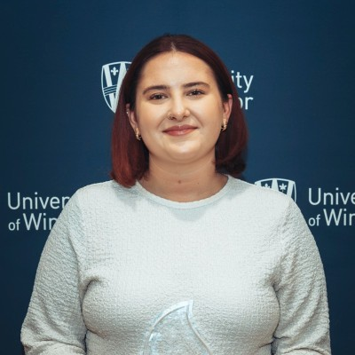
I am currently studying in the Master of Social Work & Juris Doctor program and the University of Windsor. Prior to working as a Research Assistant with The Law, Disability & Social Change Project, I have gotten to know Dr. Jacobs and work alongside her. I am inspired both by her passion that I have witnessed, and the ways this research centre combines the two disciplines I am studying. Getting to be part of this research has demonstrated to me the powerful potential of the law in creating change both in local and international domains. While finishing my Disability Studies degree, learning about Dr. Jacobs, her research, and The LDSC Project contributed to my interest in continuing my education and studying law.
I have had the privilege of taking on various tasks for The LDSC Project, including creating posts for both our website and social media accounts. I have gotten to do research regarding the Accessible Canada Act, as well as assist in organizing the webinar, Leadership in Canadian Disabled Youth Advocacy: Pathways and Intersections.
These opportunities have allowed me to deepen my understanding of disability rights and justice in the Canadian context and contribute to important conversations. The LDSC Project team has supported my academic development and gave me opportunities to learn and grow both professionally and personally. I am extremely grateful for these opportunities and look forward to the meaningful work we will get to do in the future.


Durivage Morgan, Jessyca, JD Candidate 2025
I began work with Dr. Jacobs in August 2023, when I accompanied her as a student intern to assist with her important work as a committee member on the United Nations Convention on the Rights of Persons with Disabilities (UN CRPD) as part of a Project-Based External Placements (PBEP). While there, I conducted research, prepared documents, drafted memos and briefs, corresponded with other committee members and their teams, and attended committee meetings as a notetaker. I officially joined Dr. Jacobs’ team as an RA in April, 2024 and have assisted with Dr. Jacobs’ work with the UN CRPD Committee and her Canadian advocacy work.
Working with Dr. Jacobs has changed my perspective on the power of advocacy. It is an honour to support such an incredible advocate for the rights of persons with disabilities. She taught me the importance of advocacy and exemplified diplomacy through her work as a UN CRPD Committee delegate and professor. Dr. Jacobs is not only a brilliant scholar but also careful and precise with how she advocates. She helped me find my voice and learn how to use it effectively. Being part of this team of brilliant legal minds has been an honour. When Dr. Jacobs first offered me the opportunity to work with her, I thanked her for giving me the chance, in some small way, to change the world for the better. While I have a long way to go before I can say that I have done that, I know the skills my colleagues and I have learned through working with her will empower us to create a tangible positive impact on the world. It has made me hopeful for the future of disability advocacy.

Hadwen, Dawn, JD Candidate 2025
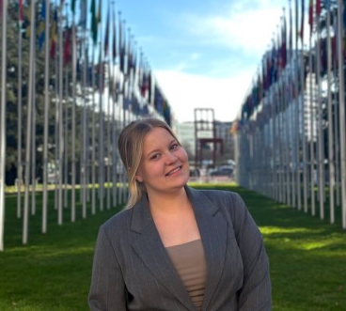
I began as a Research Assistant in the Summer of 2023. At this time, I was still navigating my role as a legal student and finding my path at Windsor Law. After working as Professor Jacobs’ Research Assistant, I gained insight into diverse roles within the legal profession and was able to foster relationships with faculty and colleagues that share and prioritize similar commitments and values as me.
I have worked on various disability research initiatives, including writing Human Rights Tribunal disability case summaries. I also contributed to various disability advocacy projects
In addition, I have conducted literature reviews on topics such as the perspectives of people with disabilities' experiences with the law, as well as critical disability studies in law, and access to housing for PWDs. Subsequently, I managed The LDSC Project’s Twitter account to share relevant disability news.
Most recently, I had the opportunity to travel to Geneva to assist Professor Jacobs at the 32nd session of the UN Committee on the Rights of Persons with Disabilities (UN CRPD). A large portion of my work focused on Article 29 – Participation in Political and Public Life, with an emphasis on the electoral rights of persons with disabilities. I also led a research project that contributed to a statement for the UN Day of General Discussion on Article 29, specifically focusing on the participation of persons with disabilities in elections.
I am grateful to have had the opportunity to deepen my understanding of disability rights on both a national and global scale, while developing professionally as a legal advocate under the mentorship of Professor Jacobs.

Jacobs, Laverne, BA (Hons) LLB, BCL, PhD |Director
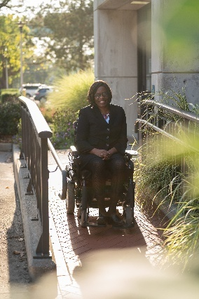
Laverne Jacobs is a Full Professor and legal scholar at the University of Windsor, Faculty of Law where she holds the Research Chair in Disability Equality & Administrative Justice. Professor Jacobs is an elected member of the United Nations Committee on the Rights of Persons with Disabilities and the first Canadian to serve on this UN Human Rights Treaty Body.
Professor Jacobs teaches, researches and writes in the areas of disability rights law, administrative law, human rights law, and administrative justice. Her work sits at the intersection of disability equality law and administrative law and justice. Her scholarship is characterized by an interest in the everyday work of the administrative justice system and in the lived experiences of the people who use it, particularly persons with disabilities. As a legal scholar, she has published and presented extensively in her fields, both in Canada and internationally. Dr. Jacobs is the recipient of a number of awards including the Canadian Bar Association Touchstone Award (2021) and the Canadian Association of Law Teachers (CALT) Academic Excellence Award (2022).
Dr. Jacobs founded and directs The Law, Disability & Social Change Project, a research and public policy centre at Windsor Law that works to foster and develop inclusive communities. She is also Co-Director of the Disability Rights Working Group at Berkeley Law’s Center for Comparative Equality & Anti-Discrimination Law. Throughout her career, Professor Jacobs has held public appointments on boards, committees and tribunals, including serving on the Board of Directors of the Income Security Advocacy Centre and of the Canadian Institute for the Administration of Justice. At the University, she was the inaugural Associate Dean (Research & Graduate Studies) for the Faculty of Law between 2018-2021.
In June 2022, Professor Jacobs was elected to the United Nations Committee on the Rights of Persons with Disabilities for a term that runs from 2023-2026. The Committee monitors the implementation of the Convention on the Rights of Persons with Disabilities (CRPD) by countries that have ratified it. UN CRPD Committee members are independent experts selected from countries around the globe. Dr. Jacobs is the first-ever Canadian to be elected to serve on the United Nations CRPD Committee, and her election is historic for that reason.

Kwok, Florence, JD 2024 |Research Coordinator

Florence says that working with The LDSC Project has been such an eye-opening experience. Not only has she been able to practically apply principles learned in class, but she has also been able to engage in the analysis of current cases. Working on The LDSC Project team has been an amazing experience for Florence who has learned to develop and strengthen her legal analytical skills. She looks forward to what is in store for the future!

Toor, Simran, JD Candidate 2026

Beginning in summer, 2024, I had the opportunity to work with The LDSC Project, where I contributed to various research and writing initiatives focused on disability rights and accessibility. One of my key responsibilities involved developing Human Rights Tribunal Summaries for publication, which required careful analysis and clear communication of legal decisions related to disability discrimination in various sectors such as employment. In addition, I supported several research projects, including examining the Canadian Transportation Agency Regulations, and tracking recent developments in disability law and news both within Canada and internationally to maintain our Twitter feed. This work continues to engage me and allows me to explore complex legal frameworks and emerging issues in disability justice, providing me with an invaluable opportunity to learn and apply my skills. My experience with The LDSC Project has been both intellectually enriching and personally meaningful, as it has allowed me to contribute to work that identifies the importance of equity and accessibility.

Williams, Samalia, Windsor Law & Detroit Mercy Law, Dual JD Candidate 2025
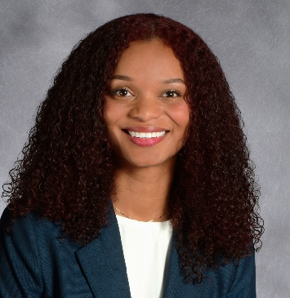
Since joining The Law, Disability & Social Change (LDSC) Project in summer, 2023, I have contributed to tribunal summaries and coded data for special projects focused on disability, access, and social justice. Our research explored how governmental bodies influence the autonomy of people living with disabilities, with a focus on Canadian jurisdictions and some comparative analysis across provinces and beyond. This experience has deepened my understanding of the systemic barriers faced by marginalized communities and the importance of advocacy-driven legal work. I greatly value the opportunity to have been a part of a project committed to equity and systemic change.

Willoughby, Deborah, MSW/JD 2021 | Research Coordinator

Deborah had the opportunity to be a part of The LDSC Project team which was one of the highlights of her MSW/JD education at Windsor Law. Being able to collaborate on meaningful projects with peers including creating the Human Rights Tribunal digests and content for The LDSC Project social media, allowed her to keep abreast of current decisions and issues as well as their implications within the community and from a global perspective. Moreover, assisting with the law and disability casebook that Dr. Jacobs was a co-author on provided Deborah with a unique lens into academia, legal research, and the dimensions of law and disability in Canada.
Deborah’s overall experience on The LDSC Project has been invaluable as it has provided her with the skills and lifelong knowledge that she is proud to utilize as she navigates her legal career. Specifically, her experience on the team has allowed her to identify and discuss the broader social impacts of issues that are often seen to be solely legal. Having this unique lens allowed her to excel as a student and will only enhance her professional career, allowing her to navigate legal issues holistically and compassionately. She was honoured to have been part of The LDSC Project team and is continuously impressed at the incredible work that the team continues to produce.

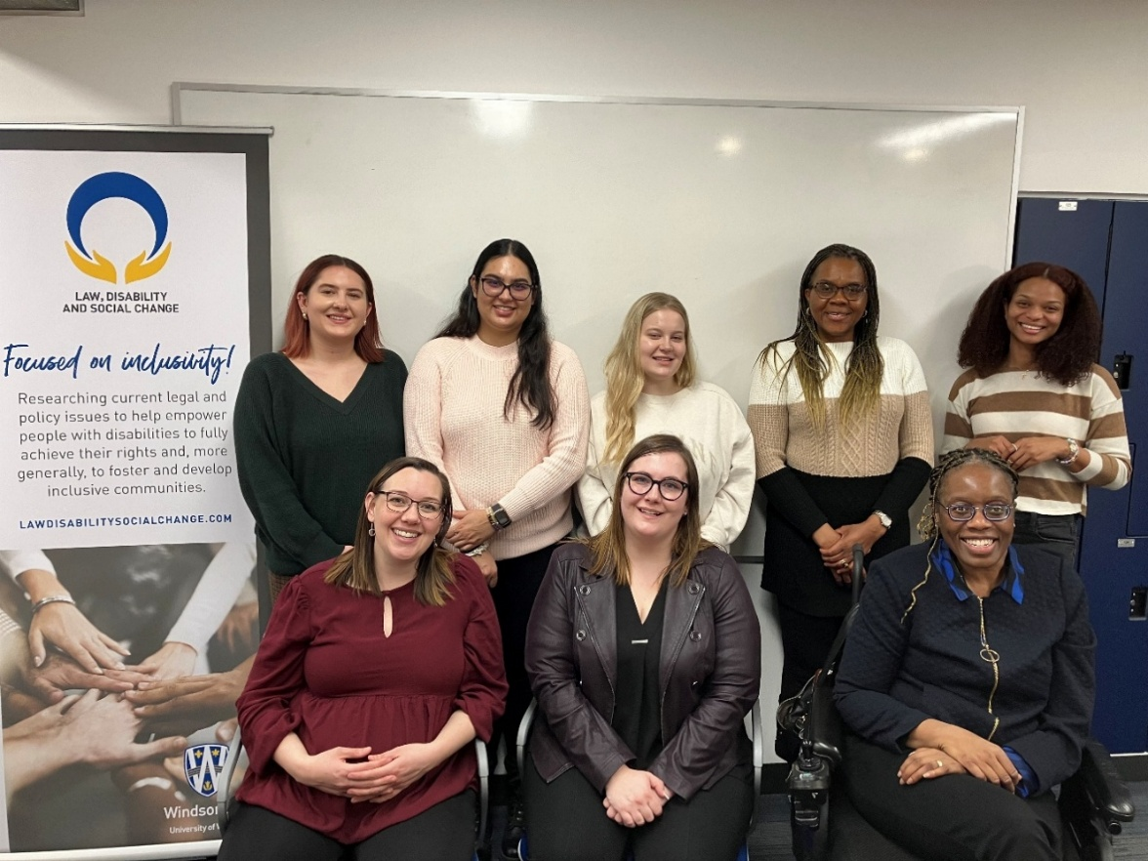
The Current Law, Disability & Social Change Project Team

Advisory Council

The Law, Disability & Social Change (LDSC) Project is guided by an Advisory Council of volunteers. The LDSC Project seeks to have guidance by diverse members of the disability community and from those who have worked with organizations dedicated to disability issues. The Advisory Council provides supportive guidance to The Law, Disability & Social Change Project including discussing and offering input on new, proposed and ongoing LDSC projects.
In 2024 – 25, we were grateful to have the support of our Advisory Council members:

- Martin Anderson, Department of Justice Canada (in his personal capacity)
- Natalia Hicks, Inclusion Canada
- Tammy Yates, Realize Canada

Acknowledgements

We are grateful to The Law Foundation of Ontario, and Windsor Law, for their generous support of this project. Additionally, we are grateful for the external research grants that help make this work possible.
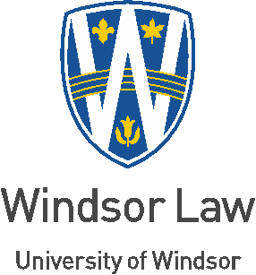
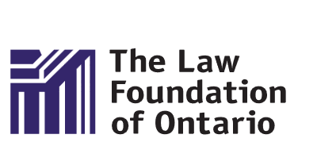

See our "About" section of this report or our "About” page on our website (click here) for more information on our vision, values and approach.

